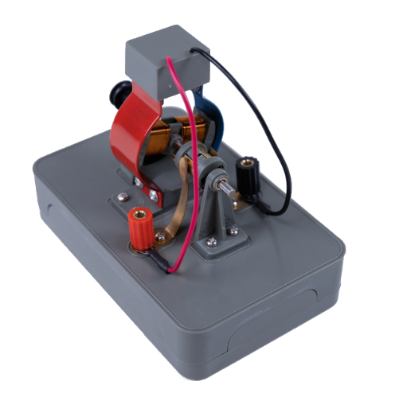
In the first part, you assembled the electric motor and connected it to a voltage source. In this part of the experiment, you put the electric motor into operation and examine how the individual components interact.
- Have your teacher approve the setup before connecting it to the power source.
- Connect the electric motor to the voltage source and set
a voltage of 3 Volts.
Turn on the voltage source and observe.
Note to teachers: The rated voltage of the electric motor is 3 - 6 V DC.
Note: The electric motor sometimes needs a push to start.

- Complete the text on how the electric motor works.
The power supply to the rotor is provided by the commutator. The sliding contacts, that are attached to the commutator are connected to a voltage source.
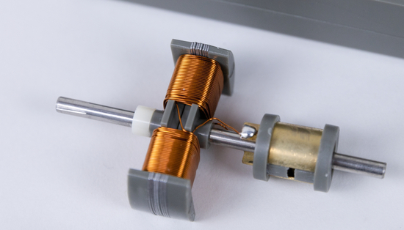
A piece of wire from the rotor is soldered to the commutator. The current flows to the coil via the commutator, creating a magnetic field.
The commutator changes the current direction of the rotor, by switching the sliding contacts to the other ring half of the commutator.
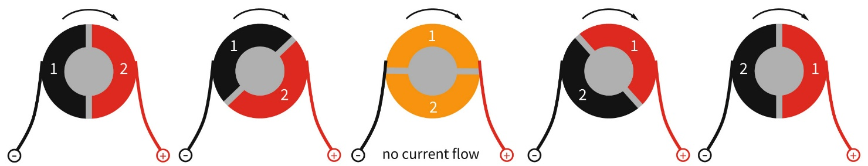
- The figure shows the two ring halves of the commutator as well as the adjacent sliding contacts that are connected to a voltage source. The gap allows the ring half 1 to change from the negative pole to the positive pole by rotation.

This reverses the magnetic field of the rotor. Thus, the magnetic field of the rotor and that of the immovable stator repel each other and the rotational movement of the rotor continues.
- Draw the direction of rotation of the rotor. In the drawing on the right, add the magnetic poles of the rotor.
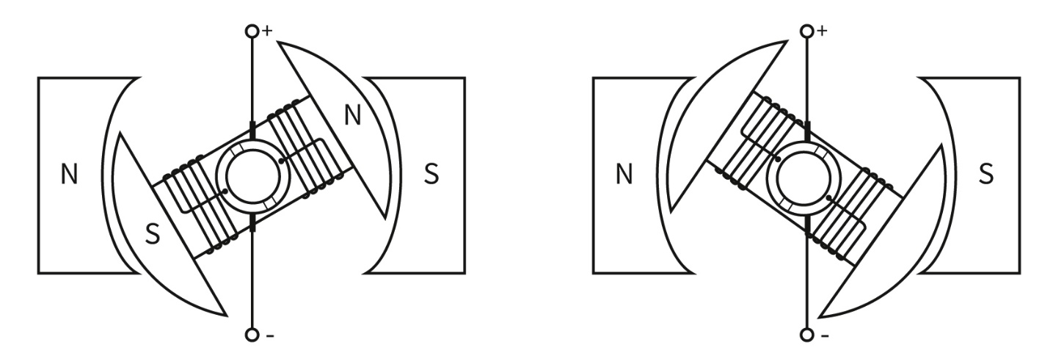
- Explain how the rotor of the electric motor must be aligned so that it only starts with a run-up.
Note: With a run-up means that you push the rotor slightly.

The rotor must be oriented in such a way that the sliding contacts touch the electrically non-conductive interruption of the commutator.

