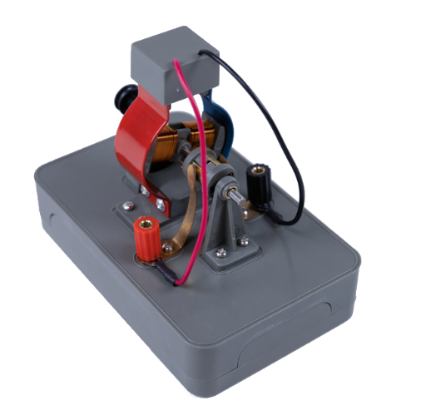
In the first part, you assembled the electric motor and connected it to a voltage source. In this part of the experiment, you put the electric motor into operation and examine how the individual components interact.
- Have your teacher approve the setup before connecting it to the power source.
- Connect the electric motor to the voltage source and set
a voltage of 3 Volts.
Turn on the voltage source and observe.
Note: The electric motor sometimes needs a push to start.

- Complete the text on how the electric motor works.
The power supply to the rotor is provided by the ________________. The _________________________, that are attached to the commutator are connected to a voltage source.
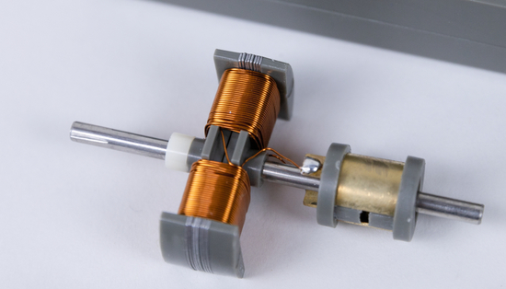
A piece of wire from the rotor is soldered to the commutator. The current flows to the coil via the commutator, creating a magnetic field.
The commutator changes the current direction of the ________________, by switching the ________________to the other ring half of the ___________________.
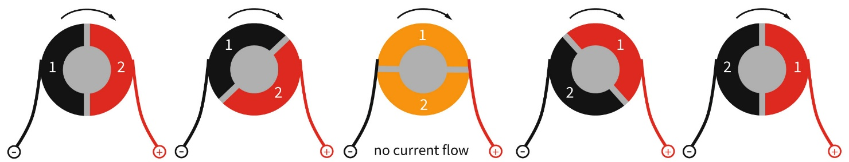
- The figure shows the two ring halves of the commutator as well as the adjacent sliding contacts that are connected to a voltage source. The gap allows the ring half 1 to change from the negative pole to the positive pole by rotation.

This reverses the magnetic field of the rotor. Thus, the magnetic field of the ________________ and that of the immovable ________________ repel each other and the rotational movement of the ________________ continues.
- Draw the direction of rotation of the rotor. In the drawing on the right, add the magnetic poles of the rotor.
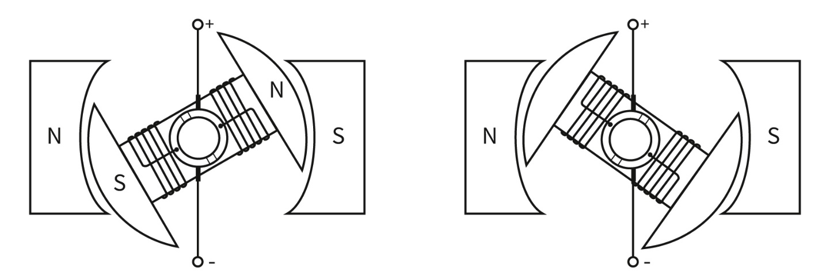
- Explain how the rotor of the electric motor must be aligned so that it only starts with a run-up.
Note: With a run-up means that you push the rotor slightly.
___________________________________________________________________________________
___________________________________________________________________________________
___________________________________________________________________________________

