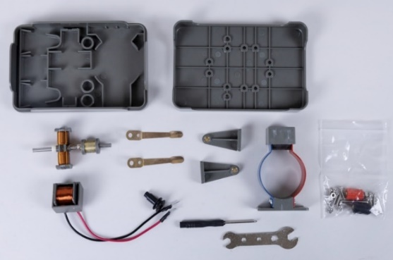
Electric motors have become an indispensable part of your everyday life. They power machines, household appliances, vehicles and much more. In this experiment, you will build a simple electric motor yourself from individual parts. You will learn the basic operating principles and investigate how the different components work together.

- Build the electric motor as independently as possible from the individual parts shown.
Note: Use the included tools as well as the screws and nuts from the bag. The markings will show you where to attach the components to the lid.
Additionally required:
Voltage source (up to 6 V)
2x Experiment cable
- Check that all rotatable components rotate well.
- Have your teacher approve the setup before connecting it to the power source.
- Do not switch on the power supply yet.
First, solve the tasks below.
Commutator
Stator Rotor

Sliding contacts

Tasks
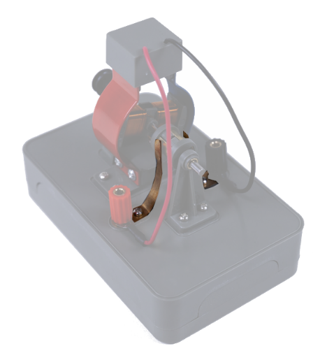
- Look up the technical terms in the cloud in your physics book. Assign the corresponding images.

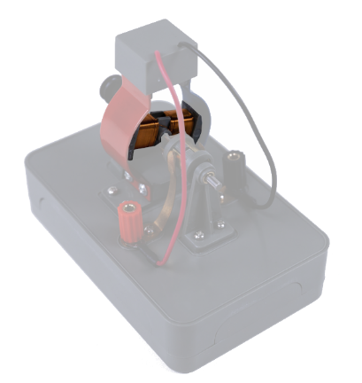

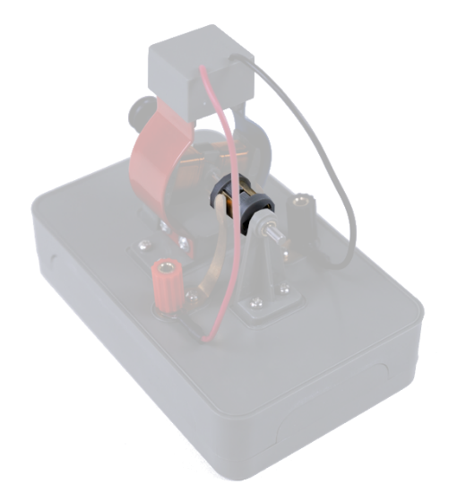
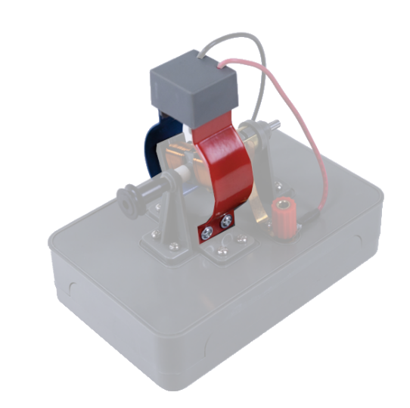

- Test your knowledge by ticking the correct answers to the following questions and statements.
Note: In the left column, several answers can be correct.
Each magnet has a  - South Pole.  - East Pole.  - West Pole.  - North Pole. | A magnet also attracts objects that do not come into contact with it.   Right   False
Poles of the same name  a) attract each other.  b) repel each other  c) are current-carrying.  d) are reinforced. | A current-carrying conductor does not generate a magnetic field in its environment.   Right   False
According to which rule can the direction of the magnetic field lines be determined?  - Four-finger rule.  - Right-hand rule.  - Left-finger rule.  - Right-finger rule. | If the cables are connected to the voltage source, the polarity of the magnetic field changes.   Right   False

- Name at least three devices that use an electric motor. Describe in a short sentence what the electric motor is used for.
___________________________________________________________________________________
___________________________________________________________________________________
___________________________________________________________________________________

